R Markdown

Muqing Xiong

2017年6月12日

library(quantmod)

## Warning: package 'quantmod' was built under R version 3.3.3

## Loading required package: xts

## Warning: package 'xts' was built under R version 3.3.3

## Loading required package: zoo

## Warning: package 'zoo' was built under R version 3.3.3

##   
## Attaching package: 'zoo'

## The following objects are masked from 'package:base':  
##   
## as.Date, as.Date.numeric

## Loading required package: TTR

## Warning: package 'TTR' was built under R version 3.3.3

## Version 0.4-0 included new data defaults. See ?getSymbols.

library(fBasics)

## Warning: package 'fBasics' was built under R version 3.3.3

## Loading required package: timeDate

## Warning: package 'timeDate' was built under R version 3.3.3

## Loading required package: timeSeries

## Warning: package 'timeSeries' was built under R version 3.3.3

##   
## Attaching package: 'timeSeries'

## The following object is masked from 'package:zoo':  
##   
## time<-

##

## Rmetrics Package fBasics

## Analysing Markets and calculating Basic Statistics

## Copyright (C) 2005-2014 Rmetrics Association Zurich

## Educational Software for Financial Engineering and Computational Science

## Rmetrics is free software and comes with ABSOLUTELY NO WARRANTY.

## https://www.rmetrics.org --- Mail to: info@rmetrics.org

##   
## Attaching package: 'fBasics'

## The following object is masked from 'package:TTR':  
##   
## volatility

library(urca)

## Warning: package 'urca' was built under R version 3.3.3

library(tseries)

## Warning: package 'tseries' was built under R version 3.3.3

library(readxl)

## Warning: package 'readxl' was built under R version 3.3.3

data1=read_excel("data1.xlsx")  
co2=data1$`co2排放量（t）`  
head(co2)

## [1] 83305.41 91759.61 103223.41 107138.26 105953.54 108416.04

co2=ts(co2,frequency=1,start = c(1994))  
plot(co2,xlab='year',ylab='t')

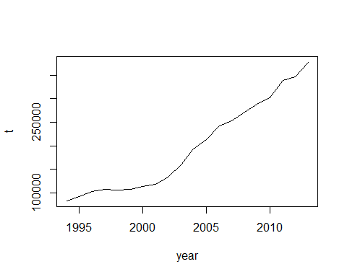

adf.test(co2)

##   
## Augmented Dickey-Fuller Test  
##   
## data: co2  
## Dickey-Fuller = -3.1119, Lag order = 2, p-value = 0.1488  
## alternative hypothesis: stationary

logco2=log(co2)  
adf.test(logco2)

##   
## Augmented Dickey-Fuller Test  
##   
## data: logco2  
## Dickey-Fuller = -4.1053, Lag order = 2, p-value = 0.01958  
## alternative hypothesis: stationary

acf(logco2,lag=20)

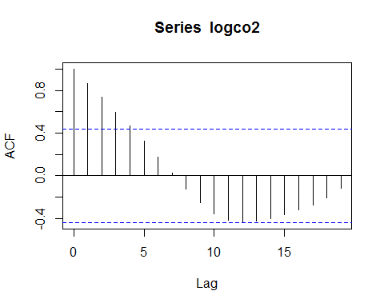

pacf(logco2,lag=20)

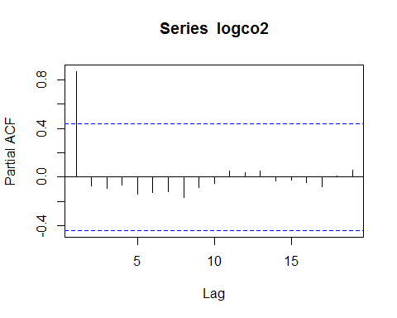

dlgco2=diff(logco2)  
adf.test(dlgco2)

##   
## Augmented Dickey-Fuller Test  
##   
## data: dlgco2  
## Dickey-Fuller = -2.15, Lag order = 2, p-value = 0.5152  
## alternative hypothesis: stationary

eh=data1$'发电设备平均利用小时'  
head(eh)

## [1] 4392 4460 4478 4389 4183 4170

eh=ts(eh,frequency = 1,start=c(1994))  
plot(eh,xlab='year',ylab='h')

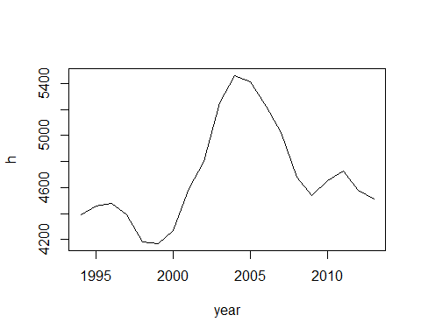

adf.test(eh)

##   
## Augmented Dickey-Fuller Test  
##   
## data: eh  
## Dickey-Fuller = -1.8178, Lag order = 2, p-value = 0.6418  
## alternative hypothesis: stationary

logeh=log(eh)  
adf.test(logeh)

##   
## Augmented Dickey-Fuller Test  
##   
## data: logeh  
## Dickey-Fuller = -1.8126, Lag order = 2, p-value = 0.6438  
## alternative hypothesis: stationary

dlgeh=diff(logeh)  
adf.test(dlgeh)

##   
## Augmented Dickey-Fuller Test  
##   
## data: dlgeh  
## Dickey-Fuller = -2.5175, Lag order = 2, p-value = 0.3752  
## alternative hypothesis: stationary

plot(dlgco2)

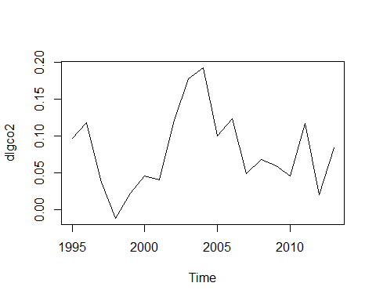

plot(dlgeh)

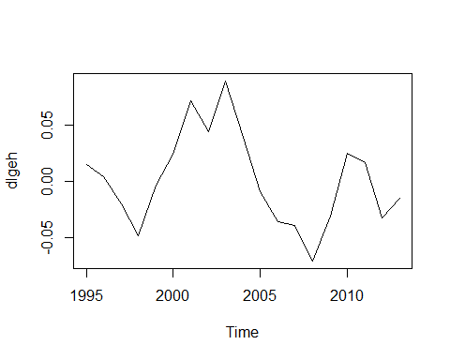

y=dlgco2  
x=dlgeh  
fit=lm(y~x)  
coef(fit)

## (Intercept) x   
## 0.07861284 0.63315049

plot(x,y,xlab="发电设备平均利用小时",ylab="co2排放量（t）")  
abline(fit)

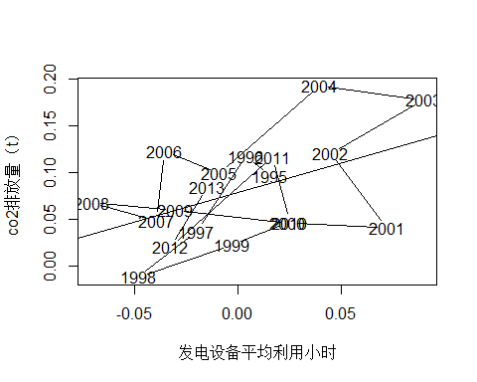

t.test(x)

##   
## One Sample t-test  
##   
## data: x  
## t = 0.14718, df = 18, p-value = 0.8846  
## alternative hypothesis: true mean is not equal to 0  
## 95 percent confidence interval:  
## -0.01867866 0.02149278  
## sample estimates:  
## mean of x   
## 0.001407061

dco2=diff(co2)  
plot(dco2)

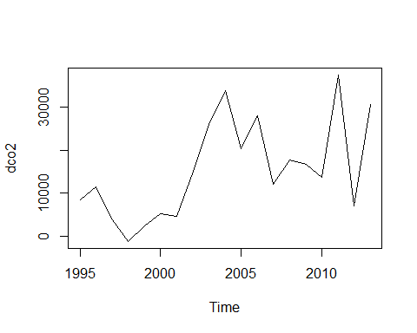

adf.test(dco2)

##   
## Augmented Dickey-Fuller Test  
##   
## data: dco2  
## Dickey-Fuller = -1.9134, Lag order = 2, p-value = 0.6054  
## alternative hypothesis: stationary

ddco2=diff(dco2)  
plot(ddco2)

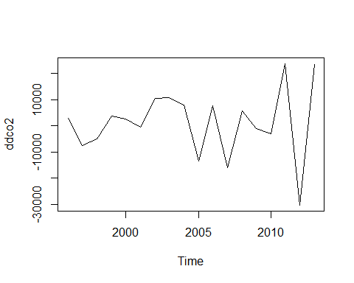

adf.test(ddco2)

##   
## Augmented Dickey-Fuller Test  
##   
## data: ddco2  
## Dickey-Fuller = -1.9674, Lag order = 2, p-value = 0.5848  
## alternative hypothesis: stationary

coal=data1$煤炭  
head(coal)

## [1] 40309.74 44600.30 50457.41 51589.21 51810.69 53189.32

coal=ts(coal,frequency=1,start = c(1994))  
plot(coal,xlab='year',ylab='t')

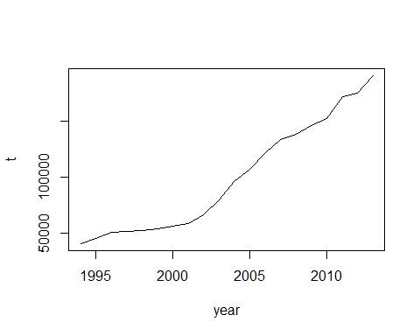

lgcoal=log(coal)  
dlgcoal=diff(lgcoal)  
x1=dlgco2  
x2=dlgeh  
x3=dlgcoal  
m1=lm(x1~x2)  
summary(m1)

##   
## Call:  
## lm(formula = x1 ~ x2)  
##   
## Residuals:  
## Min 1Q Median 3Q Max   
## -0.083322 -0.042341 0.008318 0.031009 0.089011   
##   
## Coefficients:  
## Estimate Std. Error t value Pr(>|t|)   
## (Intercept) 0.07861 0.01098 7.158 1.6e-06 ***  
## x2 0.63315 0.27058 2.340 0.0317 *   
## ---  
## Signif. codes: 0 '***' 0.001 '**' 0.01 '*' 0.05 '.' 0.1 ' ' 1  
##   
## Residual standard error: 0.04784 on 17 degrees of freedom  
## Multiple R-squared: 0.2436, Adjusted R-squared: 0.1991   
## F-statistic: 5.475 on 1 and 17 DF, p-value: 0.03174

plot(x2,x1,xlab="发电设备平均利用小时",ylab="co2排放量（t）")

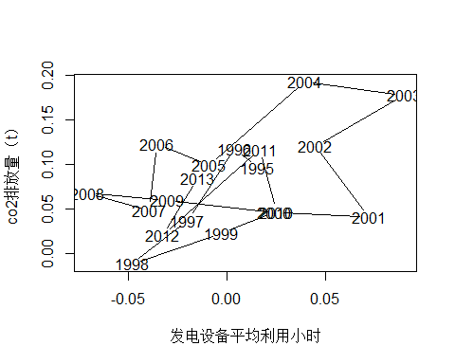

m2=lm(x1~x3)  
summary(m2)

##   
## Call:  
## lm(formula = x1 ~ x3)  
##   
## Residuals:  
## Min 1Q Median 3Q Max   
## -0.040448 -0.003194 -0.000592 0.003509 0.034962   
##   
## Coefficients:  
## Estimate Std. Error t value Pr(>|t|)   
## (Intercept) 0.001550 0.006213 0.25 0.806   
## x3 0.952580 0.063846 14.92 3.37e-11 ***  
## ---  
## Signif. codes: 0 '***' 0.001 '**' 0.01 '*' 0.05 '.' 0.1 ' ' 1  
##   
## Residual standard error: 0.01465 on 17 degrees of freedom  
## Multiple R-squared: 0.929, Adjusted R-squared: 0.9249   
## F-statistic: 222.6 on 1 and 17 DF, p-value: 3.371e-11

plot(x3,x1,xlab="发电设备平均利用小时",ylab="原煤消费量")

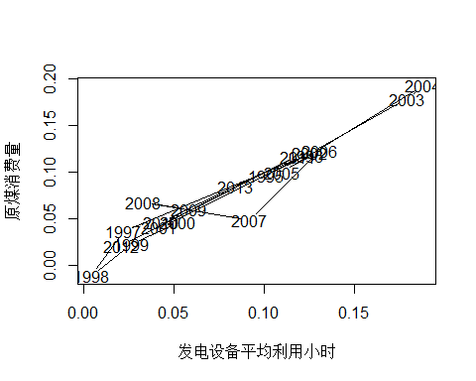

m3=lm(x2~x3)  
summary(m3)

##   
## Call:  
## lm(formula = x2 ~ x3)  
##   
## Residuals:  
## Min 1Q Median 3Q Max   
## -0.055925 -0.020454 -0.002832 0.021673 0.085692   
##   
## Coefficients:  
## Estimate Std. Error t value Pr(>|t|)   
## (Intercept) -0.02994 0.01578 -1.897 0.0749 .  
## x3 0.38300 0.16213 2.362 0.0303 *  
## ---  
## Signif. codes: 0 '***' 0.001 '**' 0.01 '*' 0.05 '.' 0.1 ' ' 1  
##   
## Residual standard error: 0.03721 on 17 degrees of freedom  
## Multiple R-squared: 0.2471, Adjusted R-squared: 0.2029   
## F-statistic: 5.581 on 1 and 17 DF, p-value: 0.03035

plot(x3,x2,xlab="原煤消费量",ylab="发电设备平均利用小时")

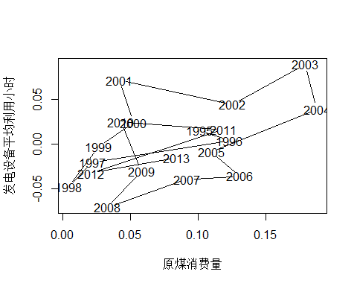

adf.test(dlgco2)

##   
## Augmented Dickey-Fuller Test  
##   
## data: dlgco2  
## Dickey-Fuller = -2.15, Lag order = 2, p-value = 0.5152  
## alternative hypothesis: stationary

adf.test(dlgeh)

##   
## Augmented Dickey-Fuller Test  
##   
## data: dlgeh  
## Dickey-Fuller = -2.5175, Lag order = 2, p-value = 0.3752  
## alternative hypothesis: stationary

adf.test(dlgcoal)

##   
## Augmented Dickey-Fuller Test  
##   
## data: dlgcoal  
## Dickey-Fuller = -2.0659, Lag order = 2, p-value = 0.5473  
## alternative hypothesis: stationary

AIC(m1)

## [1] -57.70942

AIC(m2)

## [1] -102.6742

AIC(m3)

## [1] -67.2616